Stage 3 – Consistent Professionalism
Designed by John Royer
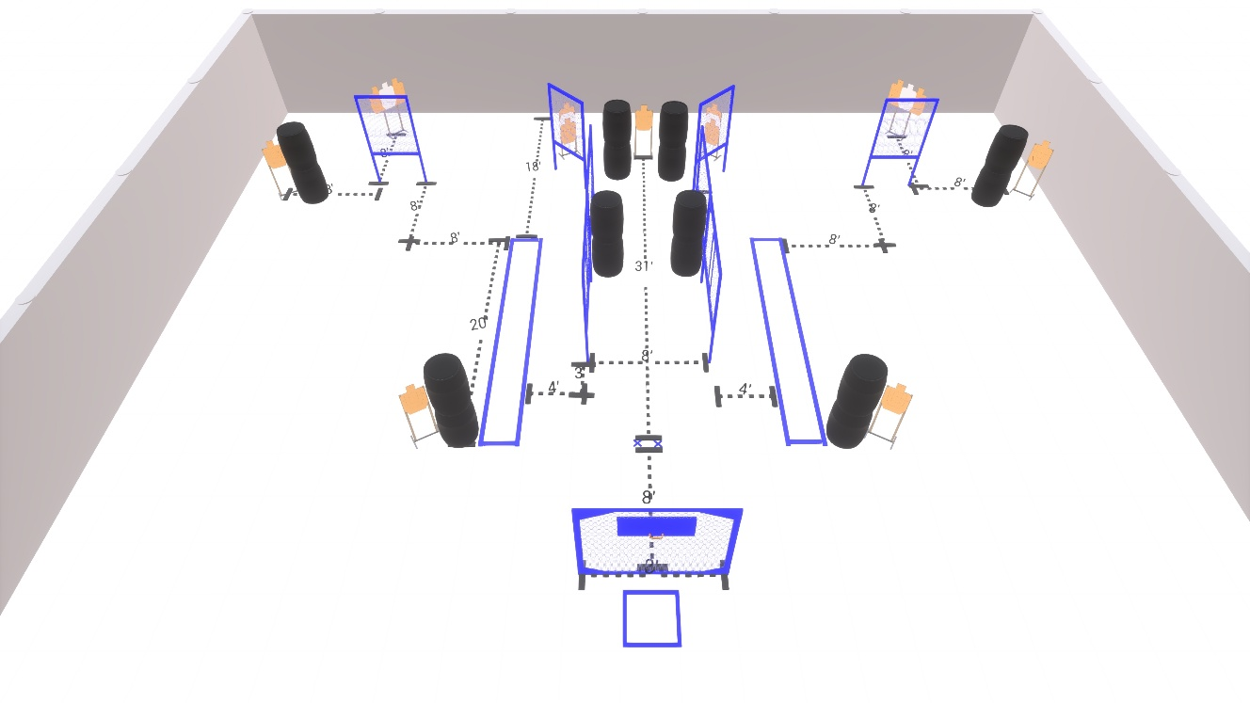
Welcome to Stage 3 - Consistent Professionalism
Sponsored by Outdoor Dynamics.
I am _____________________________, the CRO for this stage and working with me are ____________________________________________________________.
Stage 3 is a 26 round Comstock course with 13 USPSA targets.
Start position is feet straddling the start stick with toes touching rear fault line.
Handgun is loaded and holstered, with wrists below belt.
PCC is loaded with buttstock touching the belt.
At the audible start signal, engage all targets as available from within the shooting area.
Are there any questions?
You have 4 minutes to walk the stage.

